## Data-wrangling(MAT & David)

### Downloading Files Manually vs. Programmatically

# **Lesson 1**

### Best Practice: Downloading Files Programmatically

When downloading files from the internet, downloading can be done manually by clicking the download button (or sometimes right-clicking on a link and clicking "Save file as"). But best practice is actually to download files programmatically, i.e. with code, for two reasons: **scalability** and **reproducibility**.

1. **Scalability**: Imagine you had a thousand files to download on a thousand different web pages, instead of just one. It'd take an eternity to point and click a thousand times. You can do the same with a few lines of code.
2. **Reproducibility**: Someone, whether it's you or another person, is likely going to want to run your analysis later, so make downloading the dataset or datasets as easy on that person as possible. Reproducibility is also one of the main principles of the [scientific method](https://en.wikipedia.org/wiki/Scientific_method#Documentation_and_replication). You want to be able to prove to people that your analysis, visualization, etc. is legitimate. People need to know that given your data, your computational environment, your code, etc., that they can reproduce your results! Plus, the dataset or the web page it lives on may change, so if you include the date you downloaded the dataset, you give these future onlookers a chance to access archived copies of the dataset or at least understand why their results are different.

### For This Walkthrough...

To move file to working dir

|  |
| --- |
| > mv ~\Windows\Temp\armenian-online-job-postings.zip ~\Users\gk-km\Documents\DA\d-wrangling\mv |

Congratulations! You've conquered the first step of data wrangling: **gathering data**. For this dataset, this meant:

* downloading a file from the internet, which in this case was a zip file from Kaggle,
* opening a Jupyter Notebook,
* unzipping the zip file using Python,
* then importing the extracted CSV file into a pandas DataFrame in the Jupyter Notebook.

You will frequently put these skills that you’ve acquired to frequent use in your data career.

In **lesson 2**, you'll gather data using more advanced methods, like downloading files programmatically, scraping data from web pages, and accessing data from an API. You'll learn how to handle the next most popular file formats beyond CSV, like HTML, JSON, text files, and databases.

### Data Wrangling Walkthrough Checklist

For now, we'll move onto the next step in the data wrangling process: assessing data.

* Gather ✓
* Assess
* Clean

## Assess: Intro

### Properties of Data

**Quality**

Low quality data is commonly referred to as dirty data. Dirty data has issues with its content.

Imagine you had a table with two columns: Name and Height, like below:

[[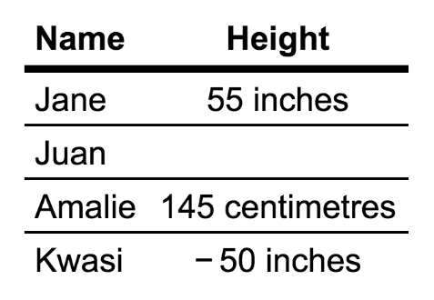](https://classroom.udacity.com/nanodegrees/nd002/parts/20a33e0b-0f64-41a3-a9d9-c6f1207265c6/modules/0bb58475-31aa-4f8d-ad2e-952f137d7fad/lessons/537d8a56-65eb-454b-87a5-5c6ba5fb4ccd/concepts/eac0a9d6-a420-4010-a37b-288001d39727)](https://classroom.udacity.com/nanodegrees/nd002/parts/20a33e0b-0f64-41a3-a9d9-c6f1207265c6/modules/0bb58475-31aa-4f8d-ad2e-952f137d7fad/lessons/537d8a56-65eb-454b-87a5-5c6ba5fb4ccd/concepts/eac0a9d6-a420-4010-a37b-288001d39727)

Common data quality issues include:

* missing data, like the missing height value for Juan.
* invalid data, like a cell having an impossible value, e.g., like negative height value for Kwasi. Having "inches" and "centimetres" in the height entries is technically invalid as well, since the datatype for height becomes a string when those are present. The datatype for height should be integer or float.
* inaccurate data, like Jane actually being 58 inches tall, not 55 inches tall.
* inconsistent data, like using different units for height (inches and centimetres).

We'll go over more tips and tricks to identify data quality issues and categorize them in the third lesson of the course.

Data quality is a perception or an assessment of data's fitness to serve its purpose in a given context. Unfortunately, that’s a bit of an evasive definition but it gets to something important: there are no hard and fast rules for data quality. One dataset may be high enough quality for one application but not for another.

**Tidiness**

Untidy data is commonly referred to as "messy" data. Messy data has issues with its structure.

Tidy data is a relatively new concept coined by statistician, professor, and all-round data expert [Hadley Wickham](http://hadley.nz/). I’m going to take a quote from his excellent [paper](https://cran.r-project.org/web/packages/tidyr/vignettes/tidy-data.html) on the subject:

It is often said that 80% of data analysis is spent on the cleaning and preparing data. And it’s not just a first step, but it must be repeated many times over the course of analysis as new problems come to light or new data is collected. To get a handle on the problem, this paper focuses on a small, but important, aspect of data cleaning that I call data tidying: structuring datasets to facilitate analysis.

...

A dataset is messy or tidy depending on how rows, columns, and tables are matched up with observations, variables, and types. In tidy data:

* Each variable forms a column.
* Each observation forms a row.
* Each type of observational unit forms a table.

[Tidy data animation from Lesson 3: Assessing Data](https://classroom.udacity.com/nanodegrees/nd002/parts/20a33e0b-0f64-41a3-a9d9-c6f1207265c6/modules/0bb58475-31aa-4f8d-ad2e-952f137d7fad/lessons/537d8a56-65eb-454b-87a5-5c6ba5fb4ccd/concepts/eac0a9d6-a420-4010-a37b-288001d39727)

Tidiness will be covered in detail in Lesson 3. If you'd like more information now, this [Tidy Data in Python](http://www.jeannicholashould.com/tidy-data-in-python.html) article by Jean-Nicholas Hould is a good start.

### Types of Assessment

2 types – visually or programmatic

**Visual Assessment**

Visual assessment is simple. Open your data in your favorite software application (Google Sheets, Excel, a text editor, etc.) and scroll through it, looking for quality and tidiness issues.

Visual assessment is painful in pandas

Problems --- not them under assessment as – your observations.

## Assess: Programmatic

### Example

**Note**: At the end of the above video, the assessment that was written down mistakenly included a verb: "***Fix*** nondescriptive column headers." Assessments should actually not include verbs and instead should only be observations of issues with the data, i.e., "Nondescriptive column headers." Verbs come into play when defining cleaning operations.

### Explore Common Programmatic Assessments

Now it's time to explore programmatic assessments for yourself! Again, this is where we use code to help detect problems in our data that aren’t as easily detectable with the human eye.

The data wrangling template is displayed in the Jupyter Notebook below with empty cells for four common programmatic assessment methods in pandas (documention pages linked below):

* [head](https://pandas.pydata.org/pandas-docs/stable/generated/pandas.DataFrame.head.html)
* [tail](https://pandas.pydata.org/pandas-docs/stable/generated/pandas.DataFrame.tail.html)
* [info](https://pandas.pydata.org/pandas-docs/stable/generated/pandas.DataFrame.info.html)
* [value_counts](https://pandas.pydata.org/pandas-docs/stable/generated/pandas.Series.value_counts.html)

Execute these assessment as per the instructions in those cells. In the following quizzes, you'll be asked to replicate these statements.

For these quizzes and all quizzes going forward, don’t go into them just trying to get them right. Exploring is a key part of learning. Get the code right, then I encourage you to explore the documentation, try various parameters, try new things and see where things break. Error messages are your friend, because you can learn from them.

**Programmatic Assessment**

Programmatic assessment tends to be more efficient than visual assessment. One simple example of a programmatic assessment is pandas' info method, which gives us the basic info of your DataFrame—like number of entries, number of columns, the types of each column, whether there are missing values, and more.

[[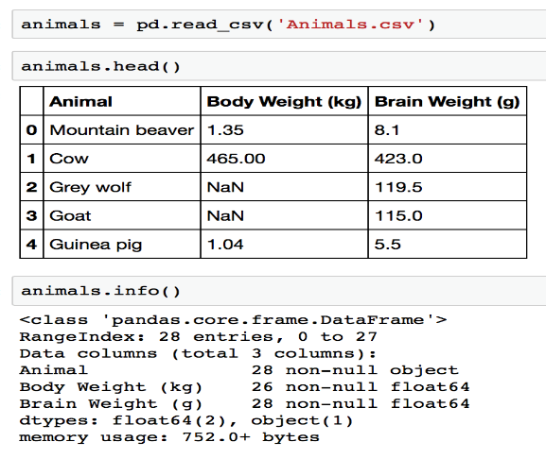](https://classroom.udacity.com/nanodegrees/nd002/parts/20a33e0b-0f64-41a3-a9d9-c6f1207265c6/modules/0bb58475-31aa-4f8d-ad2e-952f137d7fad/lessons/537d8a56-65eb-454b-87a5-5c6ba5fb4ccd/concepts/eac0a9d6-a420-4010-a37b-288001d39727)](https://classroom.udacity.com/nanodegrees/nd002/parts/20a33e0b-0f64-41a3-a9d9-c6f1207265c6/modules/0bb58475-31aa-4f8d-ad2e-952f137d7fad/lessons/537d8a56-65eb-454b-87a5-5c6ba5fb4ccd/concepts/eac0a9d6-a420-4010-a37b-288001d39727)

[pandas' info method in action on a DataFrame called](https://classroom.udacity.com/nanodegrees/nd002/parts/20a33e0b-0f64-41a3-a9d9-c6f1207265c6/modules/0bb58475-31aa-4f8d-ad2e-952f137d7fad/lessons/537d8a56-65eb-454b-87a5-5c6ba5fb4ccd/concepts/eac0a9d6-a420-4010-a37b-288001d39727) *[animals](https://classroom.udacity.com/nanodegrees/nd002/parts/20a33e0b-0f64-41a3-a9d9-c6f1207265c6/modules/0bb58475-31aa-4f8d-ad2e-952f137d7fad/lessons/537d8a56-65eb-454b-87a5-5c6ba5fb4ccd/concepts/eac0a9d6-a420-4010-a37b-288001d39727)*

Another example is using pandas' plotting capabilities through the plot method, though simple visualizations are more common in exploratory data analysis (we'll discuss this later in this lesson) rather than data wrangling.

These types of assessments are handy for gauging your data’s structure and also for quickly spotting things that we’ll need to clean.

Congratulations! That's it for the second step of data wrangling: **assessing data**. You assessed data, both visually and programmatically, and identified data quality and tidiness issues. The issues you identified were:

* Nondescriptive column headers
* Missing values (i.e. NaNs)
* Inconsistent representations of values, specifically "As soon as possible" and other similar values to "ASAP" in the StartDate column for this dataset
* A messy (i.e. untidy) dataset

There are more issues that we didn’t assess—this dataset is fairly dirty and messy—so we can’t fix everything right now. That’s okay for the purpose of this walkthrough. You've developed an eye for spotting data quality and tidiness issues, which is applicable to every dataset you'll come across in the future.

In **lesson 3**, you'll identify every common data quality and tidiness issue imaginable. You'll also refine your assessing skills. You'll be able to categorize data quality issues using four core data quality metrics. You'll also enhance your programmatic assessment skills using the most common programmatic assessment functions in pandas, including simple plotting techniques.

**Data Wrangling Walkthrough Checklist**

With our assessment notes in hand, we are ready to start cleaning, the third step in the data wrangling process.

* Gather ✓
* Assess ✓
* Clean

## Clean: Intro

### Improving Quality and Tidiness

Cleaning means acting on the assessments we made to improve quality and tidiness.

**Improving Quality**

Improving quality doesn’t mean changing the data to make it say something different—that's data fraud.

Consider the animals DataFrame, which has headers for name, body weight (in kilograms), and brain weight (in grams). The last five rows of this DataFrame are displayed below:

Examples of improving quality include:

* Correcting when inaccurate, like correcting the mouse's body weight to 0.023 kg instead of 230 kg
* Removing when irrelevant, like removing the row with "Apple" since an apple is a fruit and not an animal
* Replacing when missing, like filling in the missing value for brain weight for Brachiosaurus
* Combining, like concatenating the missing rows in the *more_animals* DataFrame displayed below

*******

xamples of improving quality include:

* Correcting when inaccurate, like correcting the mouse's body weight to 0.023 kg instead of 230 kg
* Removing when irrelevant, like removing the row with "Apple" since an apple is a fruit and not an animal
* Replacing when missing, like filling in the missing value for brain weight for Brachiosaurus
* Combining, like concatenating the missing rows in the *more_animals* DataFrame displayed below

**Improving Tidiness**

Improving tidiness means transforming the dataset so that each variable is a column, each observation is a row, and each type of observational unit is a table. There are special functions in pandas that help us do that. We'll dive deeper into those in Lesson four of this course.

### Programmatic Data Cleaning Process

**Defining, then Coding and Testing Immediately**

For pedagogical purposes in this lesson, we will be performing the define, code, and test steps of cleaning data programmatically in order. In other words, we write *all* of the definitions, then convert *all* of the definitions to code, then *test* all of the cleaning operations.

In reality, it is often more practical to define a cleaning operation, then immediately code and test it. The data wrangling template still applies here, except you'll have multiple **Define**, **Code**, and **Test** subheadings, with third level headers (###) denoting each issue, as displayed below.

[[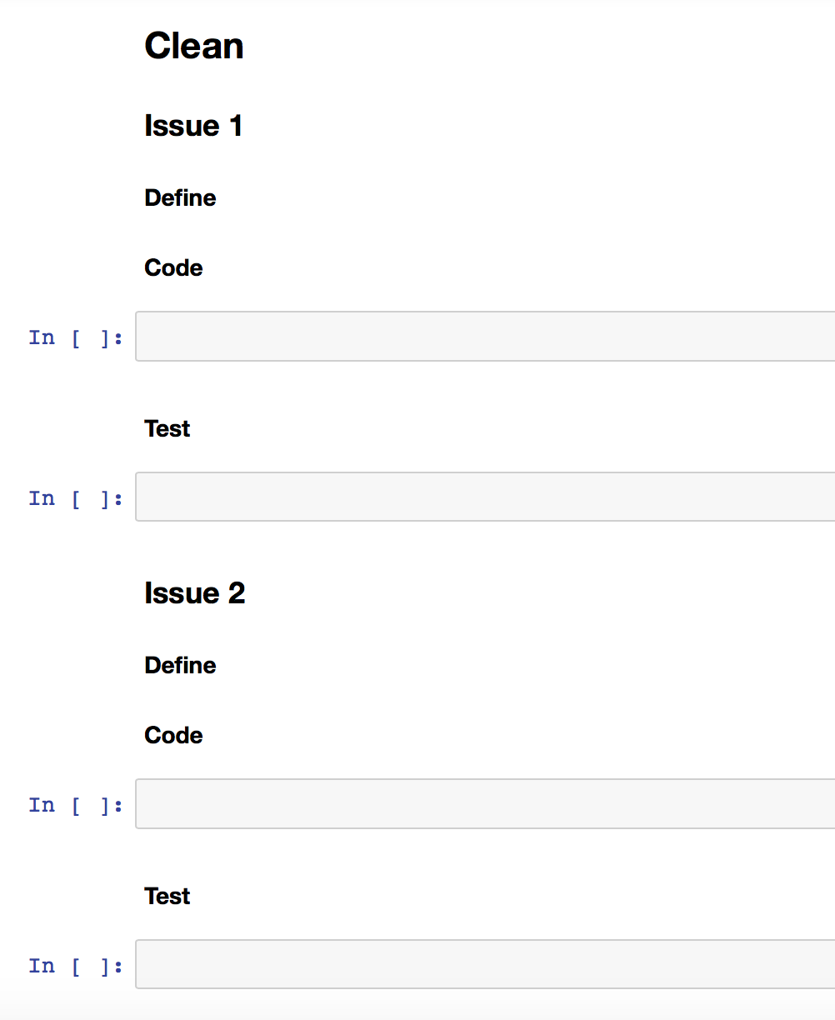](https://classroom.udacity.com/nanodegrees/nd002/parts/20a33e0b-0f64-41a3-a9d9-c6f1207265c6/modules/0bb58475-31aa-4f8d-ad2e-952f137d7fad/lessons/537d8a56-65eb-454b-87a5-5c6ba5fb4ccd/concepts/5936ae3a-1957-44e6-b0b8-651f30be8264)](https://classroom.udacity.com/nanodegrees/nd002/parts/20a33e0b-0f64-41a3-a9d9-c6f1207265c6/modules/0bb58475-31aa-4f8d-ad2e-952f137d7fad/lessons/537d8a56-65eb-454b-87a5-5c6ba5fb4ccd/concepts/5936ae3a-1957-44e6-b0b8-651f30be8264)

<https://wiki.python.org/moin/ForLoop>

https://pandas.pydata.org/pandas-docs/stable/options.html

# Clean (Summary)

## Summary: Cleaning Data

[[](https://classroom.udacity.com/nanodegrees/nd002/parts/20a33e0b-0f64-41a3-a9d9-c6f1207265c6/modules/0bb58475-31aa-4f8d-ad2e-952f137d7fad/lessons/537d8a56-65eb-454b-87a5-5c6ba5fb4ccd/concepts/37f9404a-065d-4ddf-b242-f0ceb8ebe876)](https://classroom.udacity.com/nanodegrees/nd002/parts/20a33e0b-0f64-41a3-a9d9-c6f1207265c6/modules/0bb58475-31aa-4f8d-ad2e-952f137d7fad/lessons/537d8a56-65eb-454b-87a5-5c6ba5fb4ccd/concepts/37f9404a-065d-4ddf-b242-f0ceb8ebe876)

Congratulations! You just finished cleaning, which is usually the most code-heavy part of the data wrangling process. You converted your observations from the assess step into defined problems, translated these definitions to sophisticated code to fix these problems, then tested your dataset using code—even using something software engineers use, assert statements—to make sure the operations worked.

You'll be cleaning lots more data in your future in data. So much of the world's data is dirty and messy.

The issues you cleaned in this lesson were only a subset of the most common data quality and tidiness issues. In **lesson 4**, you'll clean every common data quality and tidiness issue imaginable and you'll do it using advanced pandas techniques.

### Data Wrangling Walkthrough Checklist

So, we've gathered, assessed, and now cleaned our data. Are we done? Stay tuned.

* Gather ✓
* Assess ✓
* Clean ✓

## Storing Data (Optional)

After reassessing your data and revisiting any steps of the data wrangling process deemed necessary, storing your cleaned data can be the next logical step. Storing data is important if you need to use your cleaned data in the future.

Storing data isn't always necessary, though. Sometimes the Jupyter Notebook that you gathered, assessed, cleaned, analyzed, and visualized your data in, plus the original data files is good enough. Sometimes the analysis and visualization are the final products and you won't be using the cleaned data any further. If you ever want to reproduce the analysis, the Jupyter Notebook suffices.

This was the case for my personal example at the beginning of the lesson: wrangling hockey statistics data, creating an analysis and visualization, then [writing an article](http://bluesteam.hockey/this-years-leafs-offense-is-historically-improved/) based on that analysis and visualization and never revisiting the cleaned data again.

Storing your data, in files and databases for example, will be covered in detail in **lesson 2** of the course.

Have questions? Head to the [forums](https://knowledge.udacity.com) for discussion with the Udacity Community.

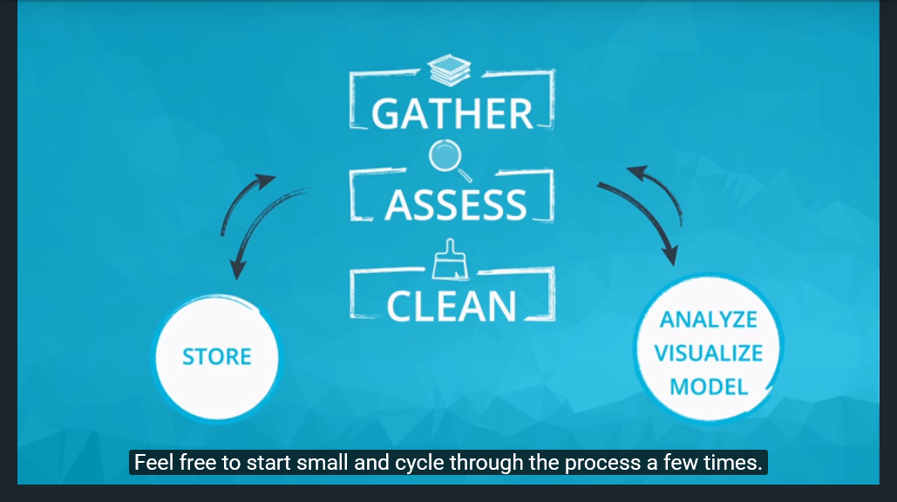

# Data Wrangling Summary

[Data wrangling template link](https://d17h27t6h515a5.cloudfront.net/topher/2017/September/59cebf3f_data-wrangling-template/data-wrangling-template.ipynb)

### Gather

* Depending on the source of your data, and what format it's in, the steps in gathering data vary.
* High-level gathering process: obtaining data (downloading a file from the internet, scraping a web page, querying an API, etc.) and importing that data into your programming environment (e.g., Jupyter Notebook).

### Assess

* Assess data for:
  + Quality: issues with content. Low quality data is also known as dirty data.
  + Tidiness: issues with structure that prevent easy analysis. Untidy data is also known as messy data. Tidy data requirements:
    1. Each variable forms a column.
    2. Each observation forms a row.
    3. Each type of observational unit forms a table.
* Types of assessment:
  + Visual assessment: scrolling through the data in your preferred software application (Google Sheets, Excel, a text editor, etc.).
  + Programmatic assessment: using code to view specific portions and summaries of the data (pandas' head, tail, and info methods, for example).

### Clean

* Types of cleaning:
  + Manual (not recommended unless the issues are single occurrences)
  + Programmatic
* The programmatic data cleaning process:
  + Define: convert our assessments into defined cleaning tasks. These definitions also serve as an instruction list so others (or yourself in the future) can look at your work and reproduce it.
  + Code: convert those definitions to code and run that code.
  + Test: test your dataset, visually or with code, to make sure your cleaning operations worked.
* Always make copies of the original pieces of data before cleaning!

### Reassess and Iterate

* After cleaning, always reassess and iterate on any of the data wrangling steps if necessary.

### Store (Optional)

* Store data, in a file or database for example, if you need to use it in the future.

# **LESSON 2 – Gathering Data**

## Lesson Outline

Data wrangling process:

* Gather (this lesson)
* Assess
* Clean

**Gathering** data is the first step in data wrangling. Before gathering, we have no data, and after it, we do.

Gathering data varies from project to project. Sometimes you're just given data, or pointed to it like I've done for you throughout this course. Sometimes you need to search for the right data for your project. Sometimes the data you need isn't readily available, and you need to generate it yourself somehow. When you do find your data, it's not unusual for it to be spread across several different sources and file formats, which makes things tricky when organizing the data in your programming environment.

For these reasons and more, gathering can be tricky. In this lesson, which is likely the most technically challenging lesson of the course, you'll acquire the coding skills and general craftiness required to conquer the vast majority of gathering scenarios you'll come across in the future. This is going to be hard sometimes, and that's okay. Stick with it and don't hesitate to reach out for help.

**This lesson will be structured as follows:**

* First, we'll pose a few questions.
* Then you'll explore the source of each piece of data we need to answer those questions, each piece from a different source and in a different format.
* Then you'll learn about the structure of each file format.
* Then you'll learn how to handle that file format using Python and its libraries.
* Then you'll actually gather each piece of data to later join together to create your master dataset.

<https://www.rottentomatoes.com/top/bestofrt/>

<http://www.rogerebert.com/>

<https://amueller.github.io/word_cloud/>

# Navigating Your Working Directory and File I/O

## Navigating Your Working Directory and File I/O

Before you continue on with this lesson, make sure you are comfortable working with your computer's command line interface to access files and folders, and also with reading and writing to files (i.e. part of File I/O or input/output) in Python. It can be extremely frustrating getting bogged down in these seemingly trivial topics.

### Command Line

For the command line interface, here are three excellent resources that I recommend. Pick whichever suits you best:

* Our short [Linux Command Line Basics](https://www.udacity.com/course/linux-command-line-basics--ud595) course (for Linux and Mac users)
* [Navigating the Terminal: A Gentle Introduction](https://computers.tutsplus.com/tutorials/navigating-the-terminal-a-gentle-introduction--mac-3855) by Marius Masalar (for Mac users)
* [Command Prompt - How to use the simple, basic commands](http://www.digitalcitizen.life/command-prompt-how-use-basic-commands) by Codrut Neagu (for Windows users)

### File I/O

For reading from and writing to files in Python:

* The "Reading from a File" concept in Lesson 5 ("Files and Modules") of our [Introduction to Python](https://www.udacity.com/course/introduction-to-python--ud1110) course

Feel free to skip these resources and continue with this lesson if you're familiar already.

**Recap of python**

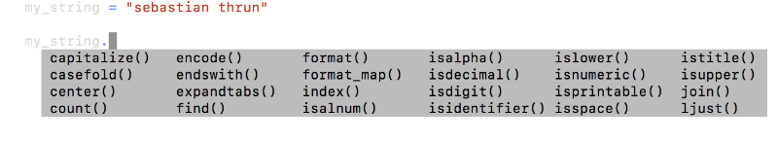

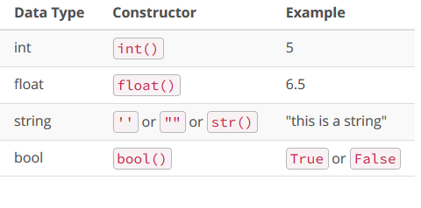

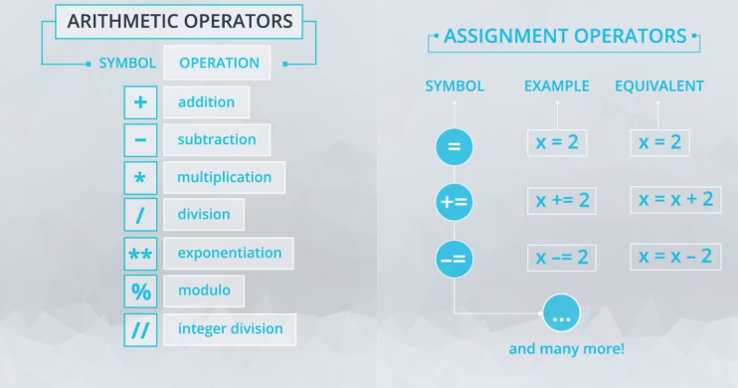

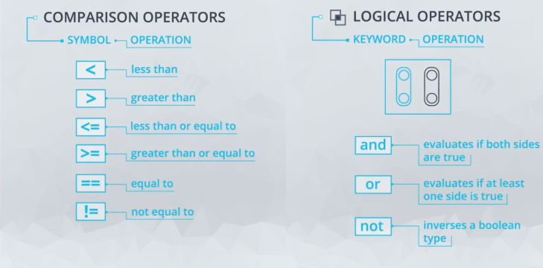

## Adding Values to Nested Dictionaries

Try your hand at working with nested dictionaries. Add another entry, 'is_noble_gas,' to each dictionary in the elements dictionary. After inserting the new entries you should be able to perform these lookups:

>>> print(elements['hydrogen']['is_noble_gas'])

False

>>> print(elements['helium']['is_noble_gas'])

True

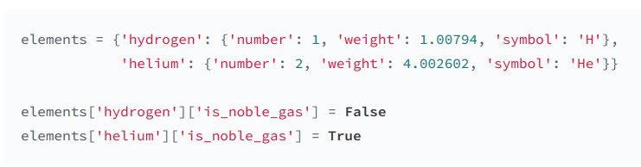

|  |
| --- |
| verse = "if you can keep your head when all about you are losing theirs and blaming it on you if you can trust yourself when all men doubt you but make allowance for their doubting too if you can wait and not be tired by waiting or being lied about don’t deal in lies or being hated don’t give way to hating and yet don’t look too good nor talk too wise"  print(verse, '\n')  # split verse into list of words  verse_list = verse.split()  print(verse_list, '\n')  # convert list to a data structure that stores unique elements  verse_set = verse_list.set()  print(verse_set, '\n')  # print the number of unique words  num_unique = len(verse_set)  print(num_unique, '\n') |

|  |
| --- |
| **Verse Dictionary**  verse_dict = {'if': 3, 'you': 6, 'can': 3, 'keep': 1, 'your': 1, 'head': 1, 'when': 2, 'all': 2, 'about': 2, 'are': 1, 'losing': 1, 'theirs': 1, 'and': 3, 'blaming': 1, 'it': 1, 'on': 1, 'trust': 1, 'yourself': 1, 'men': 1, 'doubt': 1, 'but': 1, 'make': 1, 'allowance': 1, 'for': 1, 'their': 1, 'doubting': 1, 'too': 3, 'wait': 1, 'not': 1, 'be': 1, 'tired': 1, 'by': 1, 'waiting': 1, 'or': 2, 'being': 2, 'lied': 1, 'don\'t': 3, 'deal': 1, 'in': 1, 'lies': 1, 'hated': 1, 'give': 1, 'way': 1, 'to': 1, 'hating': 1, 'yet': 1, 'look': 1, 'good': 1, 'nor': 1, 'talk': 1, 'wise': 1}  print(verse_dict, '\n')  # find number of unique keys in the dictionary  num_keys = len(verse_dict)  print(num_keys)  # find whether 'breathe' is a key in the dictionary  contains_breathe = "breathe" in verse_dict  print(contains_breathe)  # create and sort a list of the dictionary's keys  sorted_keys = sorted(verse_dict.keys())  # get the first element in the sorted list of keys  print(sorted_keys[0])  # find the element with the highest value in the list of keys  print(sorted_keys[-1]) |

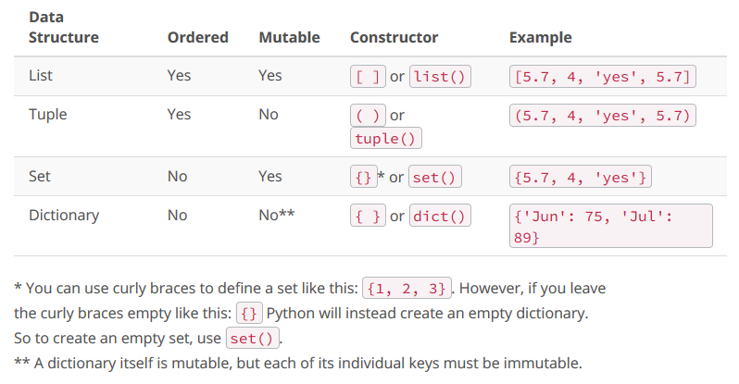

**Conditional statements**

|  |
| --- |
| #First Example - try changing the value of phone_balance  phone_balance = 10  bank_balance = 50  if phone_balance < 10:  phone_balance += 10  bank_balance -= 10  print(phone_balance)  print(bank_balance)  **#Second Example - try changing the value of number**  number = 145  if number % 2 == 0:  print("Number " + str(number) + " is even.")  else:  print("Number " + str(number) + " is odd.")  **#Third Example - try to change the value of age**  age = 35  # Here are the age limits for bus fares  free_up_to_age = 4  child_up_to_age = 18  senior_from_age = 65  # These lines determine the bus fare prices  concession_ticket = 1.25  adult_ticket = 2.50  # Here is the logic for bus fare prices  if age <= free_up_to_age:  ticket_price = 0  elif age <= child_up_to_age:  ticket_price = concession_ticket  elif age >= senior_from_age:  ticket_price = concession_ticket  else:  ticket_price = adult_ticket  message = "Somebody who is {} years old will pay ${} to ride the bus.".format(age, ticket_price)  print(message) |

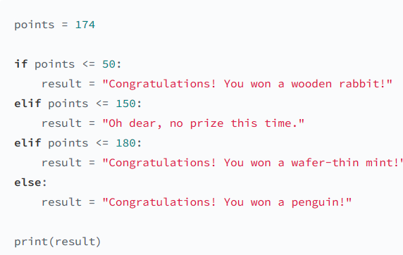

|  |
| --- |
| Using Truth Values of Objects points = 174  points = 174 # use this input when submitting your answer  # set prize to default value of None  prize = None  # use the value of points to assign prize to the correct prize name  if points <= 50:  prize = "wooden rabbit"  elif 151 <= points <= 180:  prize = "wafer-thin mint"  elif points >= 181:  prize = "penguin"  # use the truth value of prize to assign result to the correct message  if prize:  result = "Congratulations! You won a {}!".format(prize)  else:  result = "Oh dear, no prize this time."  print(result) Output Congratulations! You won a wafer-thin mint! |

|  |
| --- |
| Quiz: Guess My Number # '''  # You decide you want to play a game where you are hiding  # a number from someone. Store this number in a variable  # called 'answer'. Another user provides a number called  # 'guess'. By comparing guess to answer, you inform the user  # if their guess is too high or too low.  # Fill in the conditionals below to inform the user about how  # their guess compares to the answer.  # '''  answer = #provide answer  guess = #provide guess  if #provide conditional  result = "Oops! Your guess was too low."  elif #provide conditional  result = "Oops! Your guess was too high."  elif #provide conditional  result = "Nice! Your guess matched the answer!"  print(result)  answer = 35  guess = 30 # this is just a sample answer and guess  if guess < answer:  result = "Oops! Your guess was too low."  elif guess > answer:  result = "Oops! Your guess was too high."  elif guess==answer:  result = "Nice! Your guess matched the answer!"  print(result) Output Oops! Your guess was too low. |

# Tax Purchase

|  |
| --- |
| # '''  # Depending on where an individual is from we need to tax them  # appropriately. The states of CA, MN, and  # NY have taxes of 7.5%, 9.5%, and 8.9% respectively.  # Use this information to take the amount of a purchase and  # the corresponding state to assure that they are taxed by the right  # amount.  # '''  state = #Either CA, MN, or NY  purchase_amount = #amount of purchase  if #provide conditional for checking state is CA  tax_amount = .075  total_cost = purchase_amount*(1+tax_amount)  result = "Since you're from {}, your total cost is {}.".format(state, total_cost)  elif #provide conditional for checking state is MN  tax_amount = .095  total_cost = purchase_amount*(1+tax_amount)  result = "Since you're from {}, your total cost is {}.".format(state, total_cost)  elif #provide conditional for checking state is NY  tax_amount = .089  total_cost = purchase_amount*(1+tax_amount)  result = "Since you're from {}, your total cost is {}.".format(state, total_cost)  print(result)  state = 'CA'  purchase_amount = 20.00 # a sample state and purchase amount  if state == 'CA':  tax_amount = .075  total_cost = purchase_amount*(1+tax_amount)  result = "Since you're from {}, your total cost is {}.".format(state, total_cost)  elif state == 'MN':  tax_amount = .095  total_cost = purchase_amount*(1+tax_amount)  result = "Since you're from {}, your total cost is {}.".format(state, total_cost)  elif state == 'NY':  tax_amount = .089  total_cost = purchase_amount*(1+tax_amount)  result = "Since you're from {}, your total cost is {}.".format(state, total_cost)  print(result) Output Since you're from CA, your total cost is 21.5 |

# Boolean Expressions for Conditions

If you want to check whether a boolean is False, you can use the not operator.

|  |
| --- |
| Here are most of the built-in objects that are considered False in Python:   * constants defined to be false: None and False * zero of any numeric type: 0, 0.0, 0j, Decimal(0), Fraction(0, 1) * empty sequences and collections: '"", (), [], {}, set(), range(0)   Example:  errors = 3  if errors:  print("You have {} errors to fix!".format(errors))  else:  print("No errors to fix!")  In this code, errors has the truth value True because it's a non-zero number, so the error message is printed. This is a nice, succinct way of writing an if statement. |

|  |
| --- |
| tokens = ['<greeting>', 'Hello World!', '</greeting>','<greeting>', 'Hello World!', '</greeting>']  count = 0  for token in tokens:  if token[0] == '<' and token[-1] == '>':  count += 1  print(count) |

|  |
| --- |
| colors = ['Red', 'Blue', 'Green', 'Purple']  lower_colors = [ ]  for color in colors:  lower_colors.append(color.lower())  print(lower_colors) |
| **Iterating Through Dictionaries with For Loops**  cast = {  "Jerry Seinfeld": "Jerry Seinfeld",  "Julia Louis-Dreyfus": "Elaine Benes",  "Jason Alexander": "George Costanza",  "Michael Richards": "Cosmo Kramer"  }  Iterating through it in the usual way with a for loop would give you just the keys, as shown below:  for key in cast:  print(key)  This outputs:  Jerry Seinfeld  Julia Louis-Dreyfus  Jason Alexander  Michael Richards |
| If you wish to iterate through both keys and values, you can use the built-in method items like this:  for key, value in cast.items():  print("Actor: {} Role: {}".format(key, value))  This outputs:  Actor: Jerry Seinfeld Role: Jerry Seinfeld  Actor: Julia Louis-Dreyfus Role: Elaine Benes  Actor: Jason Alexander Role: George Costanza  Actor: Michael Richards Role: Cosmo Kramer  items is an awesome method that returns tuples of key, value pairs, which you can use to iterate over dictionaries in for loops. |

While loops

|  |
| --- |
|  |
| # number to find the factorial of  number = 6  # start with our product equal to one  product = 1  # track the current number being multiplied  current = 1  while current <= number:  # multiply the product so far by the current number  product *= current  # increment current with each iteration until it reaches number  current += 1  # print the factorial of number  print(product) |
| MUSTS for a While loop  That's right! You need to make sure the while loop has: 1) a condition expression that will be assessed and when met, will allow you to exit the loop 2) make sure the loop is advancing 3) the value of the condition variables is changing with each iteration of the loop. |
| For Loops Vs. While Loops Now that you are familiar with both for and while loops, let's consider when it's most helpful to use each of them.  **for** loops are ideal when the **number of iterations is known or finite**.  Examples:   * When you have an iterable collection (list, string, set, tuple, dictionary)   + for name in names: * When you want to iterate through a loop for a definite number of times, using range()   + for i in range(5):   **while** loops are ideal when the **iterations need to continue until a condition is met**.  Examples:   * When you want to use comparison operators   + while count <= 100: * When you want to loop based on receiving specific user input.   + while user_input == 'y': |
| https://stackoverflow.com/questions/920645/when-to-use-while-or-for-in-python |
| https://wiki.python.org/moin/WhileLoop |

|  |
| --- |
| ## Please use this space to test and run your code  num_list = [422, 136, 524, 85, 96, 719, 85, 92, 10, 17, 312, 542, 87, 23, 86, 191, 116, 35, 173, 45, 149, 59, 84, 69, 113, 166]  odd_num = 0  counter = 0  for num in num_list:  if num % 2 != 0 and counter < 5:  odd_num += num  counter += 1  print('The sum of the first five odd numbers is {}'.format(odd_num))  print ("The numbers of odd numbers added are: {}".format(counter))  print ("The sum of the odd numbers added is: {}".format(odd_num))  answer  The sum of the first five odd numbers is 993  The numbers of odd numbers added are: 5  The sum of the odd numbers added is: 993  beautiful |

|  |
| --- |
| **Break, Continue**  Sometimes we need more control over when a loop should end, or skip an iteration. In these cases, we use the break and continue keywords, which can be used in both for and while loops.  break terminates a loop  continue skips one iteration of a loop |
| manifest = [("bananas", 15), ("mattresses", 24), ("dog kennels", 42), ("machine", 120), ("cheeses", 5)]  # the code breaks the loop when weight exceeds or reaches the limit  print("METHOD 1")  weight = 0  items = []  for cargo_name, cargo_weight in manifest:  print("current weight: {}".format(weight))  if weight >= 100:  print(" breaking loop now!")  break  else:  print(" adding {} ({})".format(cargo_name, cargo_weight))  items.append(cargo_name)  weight += cargo_weight  print("\nFinal Weight: {}".format(weight))  print("Final Items: {}".format(items)) |

|  |
| --- |
| # skips an iteration when adding an item would exceed the limit  # breaks the loop if weight is exactly the value of the limit  print("\nMETHOD 2")  weight = 0  items = []  for cargo_name, cargo_weight in manifest:  print("current weight: {}".format(weight))  if weight >= 100:  print(" breaking from the loop now!")  break  elif weight + cargo_weight > 100:  print(" skipping {} ({})".format(cargo_name, cargo_weight))  continue  else:  print(" adding {} ({})".format(cargo_name, cargo_weight))  items.append(cargo_name)  weight += cargo_weight  print("\nFinal Weight: {}".format(weight))  print("Final Items: {}".format(items)) |

|  |
| --- |
| **Quiz: Break the String** Write a loop with a break statement to create a string, news_ticker, that is exactly 140 characters long. You should create the news ticker by adding headlines from the headlines list, inserting a space in between each headline. If necessary, truncate the last headline in the middle so that news_ticker is exactly 140 characters long.  Remember that break works in both for and while loops. Use whichever loop seems most appropriate. Consider adding print statements to your code to help you resolve bugs. |

|  |
| --- |
| # HINT: modify the headlines list to verify your loop works with different inputs  headlines = ["Local Bear Eaten by Man",  "Legislature Announces New Laws",  "Peasant Discovers Violence Inherent in System",  "Cat Rescues Fireman Stuck in Tree",  "Brave Knight Runs Away",  "Papperbok Review: Totally Triffic"]  news_ticker = ""  # write your loop here  news_ticker = ""  for headline in headlines:  news_ticker += headline + " "  if len(news_ticker) >= 140:  news_ticker = news_ticker[:140]  break  print(news_ticker)  print(len(news_ticker), news_ticker )  beautiful |

|  |
| --- |
| Solution for Coding Quiz: Check for Prime Numbers **Question:** Write out a code to check if the numbers provided in the list check_prime are prime numbers. If the numbers are prime, the code should print that the number is a prime number. If the number is NOT a prime number, it should print that the number is not a prime number, and also print a factor of that number besides 1 and the number itself.  **Logic for our solution:**   * We iterate through the check_prime list * Use an if-else statement and themodulo operator to check if the number when divided by another number between the range of 2 and the number itself yields any remainder. * Since we need only one factor (other than 1 and the number itself), start with 2 and break the loop checking for modulo once a factor has been identified.   check_prime = [26, 39, 51, 53, 57, 79, 85]  # iterate through the check_prime list  for num in check_prime:  # iterate through numbers ranging between 2 and the number itself  for i in range(2,num):  # number is not prime if modulo is 0  if (num % i) == 0:  print(num,"is not a prime number")  print(i, " is a factor of ", num)  break  # otherwise number is prime number  else:  print(num,"is a prime number") |
| Zip and Enumerate In the video above, at the 0:55 mark, the instructor says "... you can separate it into an items and weights list, like this," but she should instead say, "... you can separate it into an items tuple and a weights tuple, like this." Zip and Enumerate zip and enumerate are useful built-in functions that can come in handy when dealing with loops. Zip zip returns an iterator that combines multiple iterables into one sequence of tuples. Each tuple contains the elements in that position from all the iterables. For example, printing  list(zip(['a', 'b', 'c'], [1, 2, 3])) would output [('a', 1), ('b', 2), ('c', 3)].  Like we did for range() we need to convert it to a list or iterate through it with a loop to see the elements.  You could unpack each tuple in a for loop like this.  letters = ['a', 'b', 'c']  nums = [1, 2, 3]  for letter, num in zip(letters, nums):  print("{}: {}".format(letter, num))  In addition to zipping two lists together, you can also unzip a list into tuples using an asterisk.  some_list = [('a', 1), ('b', 2), ('c', 3)]  letters, nums = zip(*some_list)  This would create the same letters and nums tuples we saw earlier. **Enumerate** enumerate is a built in function that returns an iterator of tuples containing indices and values of a list. You'll often use this when you want the index along with each element of an iterable in a loop.  letters = ['a', 'b', 'c', 'd', 'e']  for i, letter in enumerate(letters):  print(i, letter)  This code would output:  0 a  1 b  2 c  3 d  4 e |

|  |
| --- |
| Quiz: Zip Coordinates Use zip to write a for loop that creates a string specifying the label and coordinates of each point and appends it to the list points. Each string should be formatted as label: x, y, z. For example, the string for the first coordinate should be F: 23, 677, 4.  x_coord = [23, 53, 2, -12, 95, 103, 14, -5]  y_coord = [677, 233, 405, 433, 905, 376, 432, 445]  z_coord = [4, 16, -6, -42, 3, -6, 23, -1]  labels = ["F", "J", "A", "Q", "Y", "B", "W", "X"]  points = []  # write your for loop here  for point in zip(labels, x_coord, y_coord, z_coord):  points.append("{}: {}, {}, {}".format(*point))  for point in points:  print(point)  answer - Notice here, the tuple was unpacked using * in the format method. This can help make your code cleaner!  F: 23, 677, 4  J: 53, 233, 16  A: 2, 405, -6  Q: -12, 433, -42  Y: 95, 905, 3  B: 103, 376, -6  W: 14, 432, 23  X: -5, 445, -1 |

|  |
| --- |
| Quiz: Zip Lists to a Dictionary Use zip to create a dictionary cast that uses names as keys and heights as values. |
| Quiz Solution: Zip Lists to a Dictionary cast_names = ["Barney", "Robin", "Ted", "Lily", "Marshall"]  cast_heights = [72, 68, 72, 66, 76]  cast = dict(zip(cast_names, cast_heights))  print(cast) Output: The order of elements in this output may vary since dictionaries are unordered.  {'Lily': 66, 'Barney': 72, 'Marshall': 76, 'Ted': 72, 'Robin': 68} |

|  |
| --- |
| Quiz: Unzip Tuples Unzip the cast tuple into two - names and heights tuples. Quiz Solution: Unzip Tuples cast = (("Barney", 72), ("Robin", 68), ("Ted", 72), ("Lily", 66), ("Marshall", 76))  names, heights = zip(*cast)  print(names)  print(heights)  ans  ('Barney', 'Robin', 'Ted', 'Lily', 'Marshall')  (72, 68, 72, 66, 76) |

|  |
| --- |
| Quiz: Transpose with Zip Use zip to transpose data from a 4-by-3 matrix to a 3-by-4 matrix. There's actually a cool trick for this! Feel free to look at the solutions if you can't figure it out. Quiz Solution: Transpose with Zip data = ((0, 1, 2), (3, 4, 5), (6, 7, 8), (9, 10, 11))  data_transpose = tuple(zip(*data))  print(data_transpose) Output: ((0, 3, 6, 9), (1, 4, 7, 10), (2, 5, 8, 11))  This is a useful trick to know! Quiz Solution: Enu |

|  |
| --- |
| Quiz: Enumerate Use enumerate to modify the cast list so that each element contains the name followed by the character's corresponding height. For example, the first element of cast should change from "Barney Stinson" to "Barney Stinson 72".  cast = ["Barney Stinson", "Robin Scherbatsky", "Ted Mosby", "Lily Aldrin", "Marshall Eriksen"]  heights = [72, 68, 72, 66, 76]  cast = ["Barney Stinson", "Robin Scherbatsky", "Ted Mosby", "Lily Aldrin", "Marshall Eriksen"]  heights = [72, 68, 72, 66, 76]  # write your for loop here  for i, character in enumerate(cast):  cast[i] = character + " " + str(heights[i])  print(cast) |

|  |
| --- |
| List Comprehensions In Python, you can create lists really quickly and concisely with list comprehensions. This example from earlier:  capitalized_cities = []  for city in cities:  capitalized_cities.append(city.title())  can be reduced to:  capitalized_cities = [city.title() for city in cities]  List comprehensions allow us to create a list using a for loop in one step.  You create a list comprehension with brackets [], including an expression to evaluate for each element in an iterable. This list comprehension above calls city.title() for each element city in cities, to create each element in the new list, capitalized_cities. Conditionals in List Comprehensions You can also add conditionals to list comprehensions (listcomps). After the iterable, you can use the if keyword to check a condition in each iteration.  squares = [x**2 for x in range(9) if x % 2 == 0]  The code above sets squares equal to the list [0, 4, 16, 36, 64], as x to the power of 2 is only evaluated if x is even. If you want to add an else, you will get a syntax error doing this.  squares = [x**2 for x in range(9) if x % 2 == 0 else x + 3]  If you would like to add else, you have to move the conditionals to the beginning of the listcomp, right after the expression, like this.  squares = [x**2 if x % 2 == 0 else x + 3 for x in range(9)]  List comprehensions are not found in other languages, but are very common in Python. |

|  |
| --- |
| Quiz: Extract First Names Use a list comprehension to create a new list first_names containing just the first names in names in lowercase. Quiz Solution: Extract First Names names = ["Rick Sanchez", "Morty Smith", "Summer Smith", "Jerry Smith", "Beth Smith"]  first_names = [name.split()[0].lower() for name in names]  print(first_names) Output: ['rick', 'morty', 'summer', 'jerry', 'beth'] |

|  |
| --- |
| Quiz: Multiples of Three Use a list comprehension to create a list multiples_3 containing the first 20 multiples of 3.  Quiz Solution: Multiples of Three  multiples_3 = [x * 3 for x in range(1, 21)]  print(multiples_3) Output: [3, 6, 9, 12, 15, 18, 21, 24, 27, 30, 33, 36, 39, 42, 45, 48, 51, 54, 57, 60] |
| Quiz: Filter Names by Scores Use a list comprehension to create a list of names passed that only include those that scored at least 65. Quiz Solution: Filter Names by Scores scores = {  "Rick Sanchez": 70,  "Morty Smith": 35,  "Summer Smith": 82,  "Jerry Smith": 23,  "Beth Smith": 98  }  passed = [name for name, score in scores.items() if score >= 65]  print(passed) Output: The order of elements in this output may vary since dictionaries are unordered.  ['Beth Smith', 'Summer Smith', 'Rick Sanchez'] |

The following questions are based on data on Oscar Award Nominations for Best Director between the years 1931 to 2010. To start you off, we've provided a dictionary called "nominated" with the year (as key) and list of directors who were nominated in that year (as value). We've provided you with a different dictionary called "winners" with the year (as key) and the director who won the award in that year (as value).

### Question 1.

**A. Create a dictionary that includes the count of Oscar nominations for each director in the nominations list.**

|  |
| --- |
| nominated = {1931: ['Norman Taurog', 'Wesley Ruggles', 'Clarence Brown', 'Lewis Milestone', 'Josef Von Sternberg'], 1932: ['Frank Borzage', 'King Vidor', 'Josef Von Sternberg'], 1933: ['Frank Lloyd', 'Frank Capra', 'George Cukor'], 1934: ['Frank Capra', 'Victor Schertzinger', 'W. S. Van Dyke'], 1935: ['John Ford', 'Michael Curtiz', 'Henry Hathaway', 'Frank Lloyd'], 1936: ['Frank Capra', 'William Wyler', 'Robert Z. Leonard', 'Gregory La Cava', 'W. S. Van Dyke'], 1937: ['Leo McCarey', 'Sidney Franklin', 'William Dieterle', 'Gregory La Cava', 'William Wellman'], 1938: ['Frank Capra', 'Michael Curtiz', 'Norman Taurog', 'King Vidor', 'Michael Curtiz'], 1939: ['Sam Wood', 'Frank Capra', 'John Ford', 'William Wyler', 'Victor Fleming'], 1940: ['John Ford', 'Sam Wood', 'William Wyler', 'George Cukor', 'Alfred Hitchcock'], 1941: ['John Ford', 'Orson Welles', 'Alexander Hall', 'William Wyler', 'Howard Hawks'], 1942: ['Sam Wood', 'Mervyn LeRoy', 'John Farrow', 'Michael Curtiz', 'William Wyler'], 1943: ['Michael Curtiz', 'Ernst Lubitsch', 'Clarence Brown', 'George Stevens', 'Henry King'], 1944: ['Leo McCarey', 'Billy Wilder', 'Otto Preminger', 'Alfred Hitchcock', 'Henry King'], 1945: ['Billy Wilder', 'Leo McCarey', 'Clarence Brown', 'Jean Renoir', 'Alfred Hitchcock'], 1946: ['David Lean', 'Frank Capra', 'Robert Siodmak', 'Clarence Brown', 'William Wyler'], 1947: ['Elia Kazan', 'Henry Koster', 'Edward Dmytryk', 'George Cukor', 'David Lean'], 1948: ['John Huston', 'Laurence Olivier', 'Jean Negulesco', 'Fred Zinnemann', 'Anatole Litvak'], 1949: ['Joseph L. Mankiewicz', 'Robert Rossen', 'William A. Wellman', 'Carol Reed', 'William Wyler'], 1950: ['Joseph L. Mankiewicz', 'John Huston', 'George Cukor', 'Billy Wilder', 'Carol Reed'], 1951: ['George Stevens', 'John Huston', 'Vincente Minnelli', 'William Wyler', 'Elia Kazan'], 1952: ['John Ford', 'Joseph L. Mankiewicz', 'Cecil B. DeMille', 'Fred Zinnemann', 'John Huston'], 1953: ['Fred Zinnemann', 'Charles Walters', 'William Wyler', 'George Stevens', 'Billy Wilder'], 1954: ['Elia Kazan', 'George Seaton', 'William Wellman', 'Alfred Hitchcock', 'Billy Wilder'], 1955: ['Delbert Mann', 'John Sturges', 'Elia Kazan', 'Joshua Logan', 'David Lean'], 1956: ['George Stevens', 'Michael Anderson', 'William Wyler', 'Walter Lang', 'King Vidor'], 1957: ['David Lean', 'Mark Robson', 'Joshua Logan', 'Sidney Lumet', 'Billy Wilder'], 1958: ['Richard Brooks', 'Stanley Kramer', 'Robert Wise', 'Mark Robson', 'Vincente Minnelli'], 1959: ['George Stevens', 'Fred Zinnemann', 'Jack Clayton', 'Billy Wilder', 'William Wyler'], 1960: ['Billy Wilder', 'Jules Dassin', 'Alfred Hitchcock', 'Jack Cardiff', 'Fred Zinnemann'], 1961: ['J. Lee Thompson', 'Robert Rossen', 'Stanley Kramer', 'Federico Fellini', 'Robert Wise', 'Jerome Robbins'], 1962: ['David Lean', 'Frank Perry', 'Pietro Germi', 'Arthur Penn', 'Robert Mulligan'], 1963: ['Elia Kazan', 'Otto Preminger', 'Federico Fellini', 'Martin Ritt', 'Tony Richardson'], 1964: ['George Cukor', 'Peter Glenville', 'Stanley Kubrick', 'Robert Stevenson', 'Michael Cacoyannis'], 1965: ['William Wyler', 'John Schlesinger', 'David Lean', 'Hiroshi Teshigahara', 'Robert Wise'], 1966: ['Fred Zinnemann', 'Michelangelo Antonioni', 'Claude Lelouch', 'Richard Brooks', 'Mike Nichols'], 1967: ['Arthur Penn', 'Stanley Kramer', 'Richard Brooks', 'Norman Jewison', 'Mike Nichols'], 1968: ['Carol Reed', 'Gillo Pontecorvo', 'Anthony Harvey', 'Franco Zeffirelli', 'Stanley Kubrick'], 1969: ['John Schlesinger', 'Arthur Penn', 'George Roy Hill', 'Sydney Pollack', 'Costa-Gavras'], 1970: ['Franklin J. Schaffner', 'Federico Fellini', 'Arthur Hiller', 'Robert Altman', 'Ken Russell'], 1971: ['Stanley Kubrick', 'Norman Jewison', 'Peter Bogdanovich', 'John Schlesinger', 'William Friedkin'], 1972: ['Bob Fosse', 'John Boorman', 'Jan Troell', 'Francis Ford Coppola', 'Joseph L. Mankiewicz'], 1973: ['George Roy Hill', 'George Lucas', 'Ingmar Bergman', 'William Friedkin', 'Bernardo Bertolucci'], 1974: ['Francis Ford Coppola', 'Roman Polanski', 'Francois Truffaut', 'Bob Fosse', 'John Cassavetes'], 1975: ['Federico Fellini', 'Stanley Kubrick', 'Sidney Lumet', 'Robert Altman', 'Milos Forman'], 1976: ['Alan J. Pakula', 'Ingmar Bergman', 'Sidney Lumet', 'Lina Wertmuller', 'John G. Avildsen'], 1977: ['Steven Spielberg', 'Fred Zinnemann', 'George Lucas', 'Herbert Ross', 'Woody Allen'], 1978: ['Hal Ashby', 'Warren Beatty', 'Buck Henry', 'Woody Allen', 'Alan Parker', 'Michael Cimino'], 1979: ['Bob Fosse', 'Francis Coppola', 'Peter Yates', 'Edouard Molinaro', 'Robert Benton'], 1980: ['David Lynch', 'Martin Scorsese', 'Richard Rush', 'Roman Polanski', 'Robert Redford'], 1981: ['Louis Malle', 'Hugh Hudson', 'Mark Rydell', 'Steven Spielberg', 'Warren Beatty'], 1982: ['Wolfgang Petersen', 'Steven Spielberg', 'Sydney Pollack', 'Sidney Lumet', 'Richard Attenborough'], 1983: ['Peter Yates', 'Ingmar Bergman', 'Mike Nichols', 'Bruce Beresford', 'James L. Brooks'], 1984: ['Woody Allen', 'Roland Joffe', 'David Lean', 'Robert Benton', 'Milos Forman'], 1985: ['Hector Babenco', 'John Huston', 'Akira Kurosawa', 'Peter Weir', 'Sydney Pollack'], 1986: ['David Lynch', 'Woody Allen', 'Roland Joffe', 'James Ivory', 'Oliver Stone'], 1987: ['Bernardo Bertolucci', 'Adrian Lyne', 'John Boorman', 'Norman Jewison', 'Lasse Hallstrom'], 1988: ['Barry Levinson', 'Charles Crichton', 'Martin Scorsese', 'Alan Parker', 'Mike Nichols'], 1989: ['Woody Allen', 'Peter Weir', 'Kenneth Branagh', 'Jim Sheridan', 'Oliver Stone'], 1990: ['Francis Ford Coppola', 'Martin Scorsese', 'Stephen Frears', 'Barbet Schroeder', 'Kevin Costner'], 1991: ['John Singleton', 'Barry Levinson', 'Oliver Stone', 'Ridley Scott', 'Jonathan Demme'], 1992: ['Clint Eastwood', 'Neil Jordan', 'James Ivory', 'Robert Altman', 'Martin Brest'], 1993: ['Jim Sheridan', 'Jane Campion', 'James Ivory', 'Robert Altman', 'Steven Spielberg'], 1994: ['Woody Allen', 'Quentin Tarantino', 'Robert Redford', 'Krzysztof Kieslowski', 'Robert Zemeckis'], 1995: ['Chris Noonan', 'Tim Robbins', 'Mike Figgis', 'Michael Radford', 'Mel Gibson'], 1996: ['Anthony Minghella', 'Joel Coen', 'Milos Forman', 'Mike Leigh', 'Scott Hicks'], 1997: ['Peter Cattaneo', 'Gus Van Sant', 'Curtis Hanson', 'Atom Egoyan', 'James Cameron'], 1998: ['Roberto Benigni', 'John Madden', 'Terrence Malick', 'Peter Weir', 'Steven Spielberg'], 1999: ['Spike Jonze', 'Lasse Hallstrom', 'Michael Mann', 'M. Night Shyamalan', 'Sam Mendes'], 2000: ['Stephen Daldry', 'Ang Lee', 'Steven Soderbergh', 'Ridley Scott', 'Steven Soderbergh'], 2001: ['Ridley Scott', 'Robert Altman', 'Peter Jackson', 'David Lynch', 'Ron Howard'], 2002: ['Rob Marshall', 'Martin Scorsese', 'Stephen Daldry', 'Pedro Almodovar', 'Roman Polanski'], 2003: ['Fernando Meirelles', 'Sofia Coppola', 'Peter Weir', 'Clint Eastwood', 'Peter Jackson'], 2004: ['Martin Scorsese', 'Taylor Hackford', 'Alexander Payne', 'Mike Leigh', 'Clint Eastwood'], 2005: ['Ang Lee', 'Bennett Miller', 'Paul Haggis', 'George Clooney', 'Steven Spielberg'], 2006: ['Alejandro Gonzaalez Inarritu', 'Clint Eastwood', 'Stephen Frears', 'Paul Greengrass', 'Martin Scorsese'], 2007: ['Julian Schnabel', 'Jason Reitman', 'Tony Gilroy', 'Paul Thomas Anderson', 'Joel Coen', 'Ethan Coen'], 2008: ['David Fincher', 'Ron Howard', 'Gus Van Sant', 'Stephen Daldry', 'Danny Boyle'], 2009: ['James Cameron', 'Quentin Tarantino', 'Lee Daniels', 'Jason Reitman', 'Kathryn Bigelow'], 2010: ['Darren Aronofsky', 'David O. Russell', 'David Fincher', 'Ethan Coen', 'Joel Coen', 'Tom Hooper']}  ### 1A: Create dictionary with the count of Oscar nominations for each director Here's the logic for my solution:  1. To solve this question, I use the .item method for dictionaries. Remember, the key in our nominated dictionary is a list of nominated directors. Think Compound Data Structures! 2. I know I need to create a dictionary where the key is a director and the value is the number of nominations. 3. But to get each director as a key, I will have to use two for loops. 4. First, to iterate through the nominated dictionary's value (which here is a list of nominations) . 5. But I have do to this again to iterate through each element (what I'm trying to get to - a nominated director) in the nominated list. 6. After that, it's simply using the .get method to create a dictionary for each director and count how many times the director's name shows up.   nom_count_dict = {}  # Add your code here  win_count_dict = {}  for year, winnerlist in winners.items():  for winner in winnerlist:  win_count_dict[winner] = win_count_dict.get(winner,0)+1  print(win_count_dict)  print("nom_count_dict = {}\n".format(nom_count_dict)) |

|  |
| --- |
| Essentially, it is the same logic as above. win_count_dict = {}  for year, winnerlist in winners.items():  for winner in winnerlist:  win_count_dict[winner] = win_count_dict.get(winner,0)+1  print(win_count_dict) |

|  |
| --- |
| Question 2 Provide a list with the name of the director(s) with the most Oscar wins. Here's the logic for my solution:  * To address this question, I will need to first create a dictionary with the number of wins by each winning director. For that I can just plug in the code we wrote for Question 1b above.  Here's the logic for my solution:  * To address this question, I will need to first create a dictionary with the number of wins by each winning director. For that I can just plug in the code we wrote for Question 1b above.   win_count_dict = {}  for year, winnerlist in winners.items():  for winner in winnerlist:  if winner not in win_count_dict:  win_count_dict[winner] = 1  else:  win_count_dict[winner] += 1  print(win_count_dict)   1. This win_count_dict dictionary provides a dictionary with the win count for the directors. We will need this to then identify which key (here, director name) has the highest value (here, win count). 2. To perform this task, we use a variable highest_count to keep track of the highest count of wins. 3. We iterate through the dictionary to see if the value for a key (i.e., wins for a director) is more than the highest count. 4. If it is, we replace that value as the highest_count. 5. Plus we add that key (here, director name) to our list tracking the most_win_director. 6. Every time we come upon a value higher than the current highest_count, we replace highest_count with the new higher value, empty the most_win_director and replace it with the new key (i.e., director's name).   using the built-in function max(), and a list comprehension with a condition:  highest_count = max(win_count_dict.values())  most_win_director = [key for key, value in win_count_dict.items() if value == highest_count]  print(most_win_director) |

**Functions - https://www.hackerrank.com/**

|  |
| --- |
| Examples:Quiz Solution: Population Density Function def population_density(population, land_area):  return population/land_area **2.** Quiz: readable_timedelta Write a function named readable_timedelta. The function should take one argument, an integer days, and return a string that says how many weeks and days that is. For example, calling the function and printing the result like this:  print(readable_timedelta(10))  should output the following:  1 week(s) and 3 day(s).  def readable_timedelta(days):  # use **integer division** to get the number of weeks  weeks = days // 7  # use **%** to get the number of days that remain  remainder = days % 7  return "{} week(s) and {} day(s).".format(weeks, remainder)  # test your function  print(readable_timedelta(10)) |
|  |
| Documentation Documentation is used to make your code easier to understand and use. Functions are especially readable because they often use documentation strings, or docstrings.  def population_density(population, land_area):  """Calculate the population density of an area.  INPUT:  population: int. The population of that area  land_area: int or float. This function is unit-agnostic, if you pass in values in terms  of square km or square miles the function will return a density in those units.  OUTPUT:  population_density: population / land_area. The population density of a particular area.  """  return population / land_area  **eg**  **def readable_timedelta(days):**  """  Return a string of the number of weeks and days included in days.  Parameters:  days -- number of days to convert (int)  Returns:  string of the number of weeks and days included in days  """  weeks = days // 7  remainder = days % 7  return "{} week(s) and {} day(s)".format(weeks, remainder) |
| Quiz: Generate Messages Imagine you're a teacher who needs to send a message to each of your students reminding them of their missing assignments and grade in the class. You have each of their names, number of missing assignments, and grades on a spreadsheet and just have to insert them into placeholders in this message you came up with:  Hi **[insert student name]**,  This is a reminder that you have **[insert number of missing assignments]** assignments left to submit before you can graduate. Your current grade is **[insert current grade]** and can increase to **[insert potential grade]** if you submit all assignments before the due date.  You can just copy and paste this message to each student and manually insert the appropriate values each time, but instead you're going to write a program that does this for you.  Write a script that does the following:   1. Ask for user input 3 times. Once for a list of names, once for a list of missing assignment counts, and once for a list of grades. Use this input to create lists for names, assignments, and grades. 2. Use a loop to print the message for each student with the correct values. The potential grade is simply the current grade added to two times the number of missing assignments.  Template code for your script: names = # get and process input for a list of names  assignments = # get and process input for a list of the number of assignments  grades = # get and process input for a list of grades  # message string to be used for each student  # HINT: use .format() with this string in your for loop  message = "Hi {},\n\nThis is a reminder that you have {} assignments left to \  submit before you can graduate. You're current grade is {} and can increase \  to {} if you submit all assignments before the due date.\n\n"  # write a for loop that iterates through each set of names, assignments, and grades to print each student's message  Below is an example of a successful run of this script in the terminal. |
| one way you can implement this program!  names = input("Enter names separated by commas: ").title().split(",")  assignments = input("Enter assignment counts separated by commas: ").split(",")  grades = input("Enter grades separated by commas: ").split(",")  message = "Hi {},\n\nThis is a reminder that you have {} assignments left to \  submit before you can graduate. You're current grade is {} and can increase \  to {} if you submit all assignments before the due date.\n\n"  for name, assignment, grade in zip(names, assignments, grades):  print(message.format(name, assignment, grade, int(grade) + int(assignment)*2)) |
| Handling ErrorsErrors and Exceptions  * **Syntax errors** occur when Python can’t interpret our code, since we didn’t follow the correct syntax for Python. These are errors you’re likely to get when you make a typo, or you’re first starting to learn Python. * **Exceptions** occur when unexpected things happen during execution of a program, even if the code is syntactically correct. There are different types of built-in exceptions in Python, and you can see which exception is thrown in the error message   Great job! There are two kinds of errors in Python - syntax errors and exceptions. Syntax errors occur when you don't use correct syntax and Python doesn't know how to run your code. Exceptions occur when Python runs into unexpected situations while executing your code and can happen even if you used correct syntax. Try Statement We can use try statements to handle exceptions. There are four clauses you can use (one more in addition to those shown in the video).   * try: This is the only mandatory clause in a try statement. The code in this block is the first thing that Python runs in a try statement. * except: If Python runs into an exception while running the try block, it will jump to the except block that handles that exception. * else: If Python runs into no exceptions while running the try block, it will run the code in this block after running the try block. * finally: Before Python leaves this try statement, it will run the code in this finally block under any conditions, even if it's ending the program. E.g., if Python ran into an error while running code in the except or else block, this finally block will still be executed before stopping the program.   [Why do we need the finally clause in Python?](https://stackoverflow.com/questions/11551996/why-do-we-need-the-finally-clause-in-python) |
| Specifying Exceptions We can actually specify which error we want to handle in an except block like this:  try:  # some code  except ValueError:  # some code  Now, it catches the ValueError exception, but not other exceptions. If we want this handler to address more than one type of exception, we can include a parenthesized tuple after the except with the exceptions.  try:  # some code  except (ValueError, KeyboardInterrupt):  # some code  Or, if we want to execute different blocks of code depending on the exception, you can have multiple except blocks.  try:  # some code  except ValueError:  # some code  except KeyboardInterrupt:  # some code |
| Practice: Handling Input ErrorsHandling Input Errors The party_planner function below takes as input a number of party people and cookies and figures out how many cookies each person gets at the party, assuming equitable distribution of cookies. Then, it returns that number along with how many cookies will be left over.  Right now, calling the function with an input of 0 people will cause an error, because it creates a ZeroDivisionError exception. Edit the party_planner function to handle this invalid input. If it runs into this exception, it should print a warning message to the user and request they input a different number of people.  After you've edited the function, try running the file again and make sure it does what you intended. Try it with several different input values, including 0 and other values for the number of people. Using this workspace In some pages of our classroom, we'll provide you a workspace like the one below that will provide you a programming environment with a Terminal and code editor, so you can do all your work right here. Here are a few tips orienting you to this kind of workspace.  On the top panel is a code editor where you can edit your Python file. Scroll up and down in this panel to see all the code. You can also expand or shrink this panel by clicking and dragging its bottom border.  On the bottom panel, you can execute this Python file by clicking on **New Terminal** and entering python handling_errors.py on the command line. |
| Here is our solution for what the revised party_planner function on the previous page could look like, using a try-except block:  def party_planner(cookies, people):  leftovers = None  num_each = None  try:  num_each = cookies // people  leftovers = cookies % people  except ZeroDivisionError:  print("Oops, you entered 0 people will be attending.")  print("Please enter a good number of people for a party.")  return(num_each, leftovers) |
| Accessing Error Messages When you handle an exception, you can still access its error message like this:  try:  # some code  except ZeroDivisionError as e:  # some code  print("ZeroDivisionError occurred: {}".format(e))  This would print something like this:  ZeroDivisionError occurred: integer division or modulo by zero  So you can still access error messages, even if you handle them to keep your program from crashing!  If you don't have a specific error you're handling, you can still access the message like this:  try:  # some code  except Exception as e:  # some code  print("Exception occurred: {}".format(e))  Exception is just the base class for all built-in exceptions. You can learn more about Python's exceptions [here](https://docs.python.org/3/library/exceptions.html#bltin-exceptions).  https://docs.python.org/3/library/exceptions.html#bltin-exceptions |
| Reading and Writing Files To follow along with the example above, create a new file in Atom, copy the following text into it, and save it as some_file.txt!  Hello!!  You've read the contents of this file!  Here's how we read and write files in Python. Reading a File f = open('my_path/my_file.txt', 'r')  file_data = f.read()  f.close()   1. First open the file using the built-in function, open. This requires a string that shows the path to the file. The open function returns a file object, which is a Python object through which Python interacts with the file itself. Here, we assign this object to the variable f. 2. There are optional parameters you can specify in the open function. One is the mode in which we open the file. Here, we use r or read only. This is actually the default value for the mode argument. 3. Use the read method to access the contents from the file object. This read method takes the text contained in a file and puts it into a string. Here, we assign the string returned from this method into the variable file_data. 4. When finished with the file, use the close method to free up any system resources taken up by the file.  Writing to a File f = open('my_path/my_file.txt', 'w')  f.write("Hello there!")  f.close()   1. Open the file in writing ('w') mode. If the file does not exist, Python will create it for you. If you open an existing file in writing mode, any content that it had contained previously will be deleted. If you're interested in adding to an existing file, without deleting its content, you should use the append ('a') mode instead of write. 2. Use the write method to add text to the file. 3. Close the file when finished.  Too Many Open Files Run the following script in Python to see what happens when you open too many files without closing them!  files = []  for i in range(10000):  files.append(open('some_file.txt', 'r'))  print(i) |
| With Python provides a special syntax that auto-closes a file for you once you're finished using it.  with open('my_path/my_file.txt', 'r') as f:  file_data = f.read()  This with keyword allows you to open a file, do operations on it, and automatically close it after the indented code is executed, in this case, reading from the file. Now, we don’t have to call f.close()! You can only access the file object, f, within this indented block. |
| Quiz: Reading and Writing FilesCalling the read Method with an Integer In the code you saw earlier, the call to f.read() had no arguments passed to it. This defaults to reading all the remainder of the file from its current position - the whole file. If you pass the read method an integer argument, it will read up to that number of characters, output all of them, and keep the 'window' at that position ready to read on.  Let's see this in an example that uses the following file, camelot.txt:  We're the knights of the round table  We dance whenever we're able  Here's a script that reads in the file a little at a time by passing an integer argument to .read().  with open("camelot.txt") as song:  print(song.read(2))  print(song.read(8))  print(song.read())  Outputs:  We  're the  knights of the round table  We dance whenever we're able  You can try out this example by creating your own camelot.txt and example.py files with the text above.  Each time we called read on the file with an integer argument, it read up to that number of characters, outputted them, and kept the 'window' at that position for the next call to read. This makes moving around in the open file a little tricky, as there aren't many landmarks to navigate by. Reading Line by Line \ns in blocks of text are newline characters. The newline character marks the end of a line, and tells a program (such as a text editor) to go down to the next line. However, looking at the stream of characters in the file, \n is just another character.  Fortunately, Python knows that these are special characters and you can ask it to read one line at a time. Let's try it!  Conveniently, Python will loop over the lines of a file using the syntax for line in file. I can use this to create a list of lines in the file. Because each line still has its newline character attached, I remove this using .strip().  camelot_lines = []  with open("camelot.txt") as f:  for line in f:  camelot_lines.append(line.strip())  print(camelot_lines)  Outputs:  ["We're the knights of the round table", "We dance whenever we're able"] |
| ["We're the knights of the round table", "We dance whenever we're able"] Quiz: Flying Circus Cast List You're going to create a list of the actors who appeared in the television programme Monty Python's Flying Circus.  Write a function called create_cast_list that takes a filename as input and returns a list of actors' names. It will be run on the file flying_circus_cast.txt (this information was collected from imdb.com). Each line of that file consists of an actor's name, a comma, and then some (messy) information about roles they played in the programme. You'll need to extract only the name and add it to a list. You might use the [.split() method](https://docs.python.org/3/library/stdtypes.html#str.split) to process each line. def create_cast_list(filename):cast_list = []#use with to open the file filename#use the for loop syntax to process each line#and add the actor name to cast_listreturn cast_listcast_list = create_cast_list('flying_circus_cast.txt')for actor in cast_list:print(actor) |
| Quiz Solution: Flying Circus Cast List def create_cast_list(filename):  cast_list = []  with open(filename) as f:  for line in f:  name = line.split(",")[0]  cast_list.append(name)  return cast_list  cast_list = create_cast_list('flying_circus_cast.txt')  for actor in cast_list:  print(actor) |

[**https://pymotw.com/3/**](https://pymotw.com/3/)

|  |
| --- |
| Techniques for Importing Modules There are other variants of import statements that are useful in different situations.   1. To import an individual function or class from a module: 2. from module_name import object_name 3. To import multiple individual objects from a module: 4. from module_name import first_object, second_object 5. To rename a module: 6. import module_name as new_name 7. To import an object from a module and rename it: 8. from module_name import object_name as new_name 9. To import every object individually from a module (DO NOT DO THIS): 10. from module_name import * 11. If you really want to use all of the objects from a module, use the standard import module_name statement instead and access each of the objects with the dot notation. 12. import module_name |

|  |
| --- |
| Third-Party Libraries There are tens of thousands of third-party libraries written by independent developers! You can install them using pip, a package manager that is included with Python 3. pip is the standard package manager for Python, but it isn't the only one. One popular alternative is Anaconda which is designed specifically for data science.  To install a package using pip, just enter "pip install" followed by the name of the package in your command line like this: pip install package_name. This downloads and installs the package so that it's available to import in your programs. Once installed, you can import third-party packages using the same syntax used to import from the standard library. Using a requirements.txt File Larger Python programs might depend on dozens of third party packages. To make it easier to share these programs, programmers often list a project's dependencies in a file called requirements.txt. This is an example of a requirements.txt file.  beautifulsoup4==4.5.1  bs4==0.0.1  pytz==2016.7  requests==2.11.1  Each line of the file includes the name of a package and its version number. The version number is optional, but it usually should be included. Libraries can change subtly, or dramatically, between versions, so it's important to use the same library versions that the program's author used when they wrote the program.  You can use pip to install all of a project's dependencies at once by typing pip install -r requirements.txt in your command line. Useful Third-Party Packages Being able to install and import third party libraries is useful, but to be an effective programmer you also need to know what libraries are available for you to use. People typically learn about useful new libraries from online recommendations or from colleagues. If you're a new Python programmer you may not have many colleagues, so to get you started here's a list of packages that are popular with engineers at Udacity.   * [IPython](https://ipython.org/) - A better interactive Python interpreter * [requests](http://docs.python-requests.org/) - Provides easy to use methods to make web requests. Useful for accessing web APIs. * [Flask](http://flask.pocoo.org/) - a lightweight framework for making web applications and APIs. * [Django](https://www.djangoproject.com/) - A more featureful framework for making web applications. Django is particularly good for designing complex, content heavy, web applications. * [Beautiful Soup](https://www.crummy.com/software/BeautifulSoup/) - Used to parse HTML and extract information from it. Great for web scraping. * [pytest](http://doc.pytest.org/) - extends Python's builtin assertions and unittest module. * [PyYAML](http://pyyaml.org/wiki/PyYAML) - For reading and writing [YAML](https://en.wikipedia.org/wiki/YAML) files. * [NumPy](http://www.numpy.org/) - The fundamental package for scientific computing with Python. It contains among other things a powerful N-dimensional array object and useful linear algebra capabilities. * [pandas](http://pandas.pydata.org/) - A library containing high-performance, data structures and data analysis tools. In particular, pandas provides dataframes! * [matplotlib](http://matplotlib.org/) - a 2D plotting library which produces publication quality figures in a variety of hardcopy formats and interactive environments. * [ggplot](http://ggplot.yhathq.com/) - Another 2D plotting library, based on R's ggplot2 library. * [Pillow](https://python-pillow.org/) - The Python Imaging Library adds image processing capabilities to your Python interpreter. * [pyglet](http://www.pyglet.org/) - A cross-platform ap |
| To quit the Python interactive interpreter, use the command exit() or hit ctrl-D on mac or linux, and ctrl-Z then Enter for windows. IPython There is actually an awesome alternative to the default Python interactive interpreter, IPython, which comes with many additional features.   * tab completion * ? for details about an object * ! to execute system shell commands * syntax highlighting!   and a lot more you can find [here](https://ipython.org/ipython-doc/3/interactive/tutorial.html)! https://ipython.org/ipython-doc/3/interactive/tutorial.html |

|  |
| --- |
| Hierarchy of Online Resources While there are many online resources about programming, not all of the them are created equal. This list of resources is in approximate order of reliability.   1. [**The Python Tutorial**](https://docs.python.org/3/tutorial/) - This section of the official documentation surveys Python's syntax and standard library. It uses examples, and is written using less technical language than the main documentation. Make sure you're reading the Python 3 version of the docs! 2. [**The Python Language and Library References**](https://docs.python.org/3/index.html) - The Language Reference and Library Reference are more technical than the tutorial, but they are the definitive sources of truth. As you become increasingly acquainted with Python you should use these resources more and more. 3. **Third-Party Library Documentation** - Third-party libraries publish their documentation on their own websites, and often times at <https://readthedocs.org/>. You can judge the quality of a third-party library by the quality of its documentation. If the developers haven't found time to write good docs, they probably haven't found the time to polish their library either. 4. **The websites and blogs of prominent experts** - The previous resources are primary sources, meaning that they are documentation from the same people who wrote the code being documented. Primary sources are the most reliable. Secondary sources are also extremely valuable. The difficulty with secondary sources is determining the credibility of the source. The websites of authors like [Doug Hellmann](https://doughellmann.com/blog/) and developers like [Eli Bendersky](http://eli.thegreenplace.net/) are excellent. The blog of an unknown author might be excellent, or it might be rubbish. 5. [**StackOverflow**](http://stackoverflow.com/) - This question and answer site has a good amount of traffic, so it's likely that someone has asked (and someone has answered) a related question before! However, answers are provided by volunteers and vary in quality. Always understand solutions before putting them into your program. One line answers without any explanation are dubious. This is a good place to find out more about your question or discover alternative search terms. 6. **Bug Trackers** - Sometimes you'll encounter a problem so rare, or so new, that no one has addressed it on StackOverflow. You might find a reference to your error in a bug report on GitHub for instance. These bug reports can be helpful, but you'll probably have to do some original engineering work to solve the problem. 7. **Random Web Forums** - Sometimes your search yields references to forums that haven't been active since 2004, or some similarly ancient time. If these are the only resources that address your problem, you should rethink how you're approaching your solution. |

**End of - Recap of python**

**Continue with gathering data – d-wrangling!!!**

[**https://d17h27t6h515a5.cloudfront.net/topher/2017/September/59ca594d_bestofrt/bestofrt.tsv**](https://d17h27t6h515a5.cloudfront.net/topher/2017/September/59ca594d_bestofrt/bestofrt.tsv)

* [Rotten Tomatoes Top 100 Movies of All Time TSV File](https://d17h27t6h515a5.cloudfront.net/topher/2017/September/59ca594d_bestofrt/bestofrt.tsv) *(Note: this file will be provided in a Jupyter Notebook workspace so you only need to download this file if you want it outside of the Udacity classroom)*

*Note: Internal data from a database can be downloaded programmatically from the file storage systems (like Google Drive) for some companies, though it is often trickier than downloading a file hosted on a web page. In practice, internal files aren't often downloaded programmatically for wrangling and analysis/visualization/modeling.*

Have questions? Head to the [forums](https://knowledge.udacity.com) for discussion with the Udacity Community.

[**https://www.cac.cornell.edu/education/Training/DataAnalysis/RelationalDatabases.pdf**](https://www.cac.cornell.edu/education/Training/DataAnalysis/RelationalDatabases.pdf)

|  |
| --- |
| **df = pd.read_csv('bestofrt.tsv', sep='\t')** |

https://pandas.pydata.org/pandas-docs/stable/generated/pandas.read_csv.html

The two main ways to work with HTML files are:

* Saving the HTML file to your computer (using the [Requests](http://docs.python-requests.org/en/master/) library for example) library and reading that file into a [BeautifulSoup](https://www.crummy.com/software/BeautifulSoup/) constructor
* Reading the HTML response content directly into a BeautifulSoup constructor (again using the Requests library for example)

You'll learn how this Requests code works under the hood shortly in “Downloading Files from The Internet.”

For this lesson, you’re going to do neither of these. I've downloaded all of the Rotten Tomatoes HTML files for you and put them in a folder called rt_html in the Jupyter Notebooks in the Udacity classroom. If you want to work outside of the classroom, **download** [**this zip file**](https://d17h27t6h515a5.cloudfront.net/topher/2017/September/59ca6b7b_rt-html/rt-html.zip) **and extract the rt_html folder. I recommend that you do and open the HTML files in your preferred text editor (e.g.** [**Sublime**](https://www.sublimetext.com/)**, which is free) to inspect the HTML for the quizzes ahead.**

The rt_html folder contains the Rotten Tomatoes HTML for each of the Top 100 Movies of All Time as the list stood at the most recent update of this lesson. I'm giving you these historical files because the ratings will change over time and there will be inconsistencies with the recorded lesson videos. Also, a web page's HTML is known to change over time. Scraping code can break easily when web redesigns occur, which makes scraping brittle and not recommended for projects with longevity. So just use these HTML files provided to you and pretend like you saved them yourself with one of the methods described above.

### More Information

* [Towards Data Science: Ethics in Web Scraping](https://medium.com/towards-data-science/ethics-in-web-scraping-b96b18136f01)
* [David Venturi: Screen scraping was the first "magical" thing that drew me to programming](https://twitter.com/venturidb/status/734757220525715456)

<https://towardsdatascience.com/ethics-in-web-scraping-b96b18136f01>

<https://twitter.com/venturidb/status/734757220525715456>

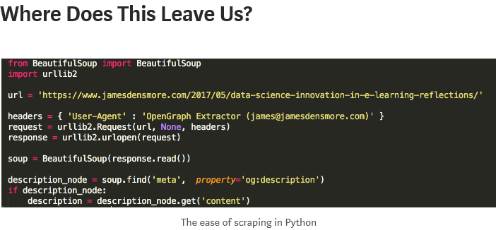

Wow - <https://blog.udacity.com/2015/03/3-web-developers-built-careers-scratch-part-two-cameron-pittman.html>

|  |
| --- |
| Beautiful Soup is a Python library designed for quick turnaround projects like screen-scraping. Three features make it powerful:   1. Beautiful Soup provides a few simple methods and Pythonic idioms for navigating, searching, and modifying a parse tree: a toolkit for dissecting a document and extracting what you need. It doesn't take much code to write an application 2. Beautiful Soup automatically converts incoming documents to Unicode and outgoing documents to UTF-8. You don't have to think about encodings, unless the document doesn't specify an encoding and Beautiful Soup can't detect one. Then you just have to specify the original encoding. 3. Beautiful Soup sits on top of popular Python parsers like [lxml](http://lxml.de/) and [html5lib](http://code.google.com/p/html5lib/), allowing you to try out different parsing strategies or trade speed for flexibility.   Beautiful Soup parses anything you give it, and does the tree traversal stuff for you. You can tell it "Find all the links", or "Find all the links of class externalLink", or "Find all the links whose urls match "foo.com", or "Find the table heading that's got bold text, then give me that text."  Valuable data that was once locked up in poorly-designed websites is now within your reach. Projects that would have taken hours take only minutes with Beautiful Soup. |
| What is web scraping? It's the process of extracting information from a web page **by taking advantage of patterns** in the web page's underlying code. Let's start looking for these patterns! |

<https://www.youtube.com/redirect?redir_token=k6mJ2EfYfug4snuTtYAdnD3pTDZ8MTU0MzM5NDU5OUAxNTQzMzA4MTk5&q=https%3A%2F%2Fgithub.com%2Fjustmarkham%2Ftrump-lies&event=video_description&v=v5DDW5dyfyc>

<https://www.youtube.com/watch?v=v5DDW5dyfyc>

Keep testing at each step using break before you add the next step

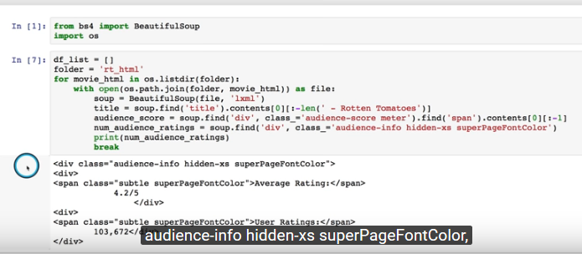

<span class="superPageFontColor" style="vertical-align:top">72%</span>

<div class="meter-value">

<span class="superPageFontColor" style="vertical-align:top">72%</span>

</div>

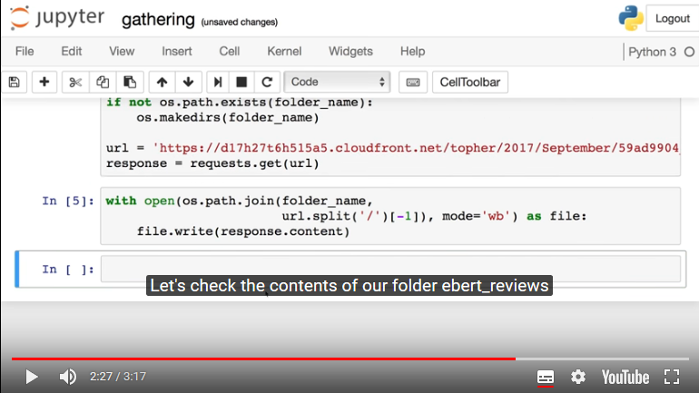

In general, however, you should use a pattern like this to save what is being streamed to a file:

with open(filename, 'wb') as fd:

for chunk in r.iter_content(chunk_size=128):

fd.write(chunk)

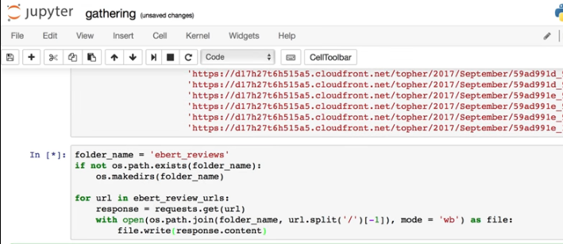

|  |
| --- |
| Reading and Writing JSON to a File in Python |
| <https://stackabuse.com/reading-and-writing-json-to-a-file-in-python/> https://en.wikipedia.org/wiki/JSON#Data_types.2C_syntax_and_example  The easiest way to write your data in the JSON format to a file using Python is to use store your data in a dict object, which can contain other nested dicts, arrays, booleans, or other primitive types like integers and strings. You can find a more detailed list of data types supported [here](https://en.wikipedia.org/wiki/JSON#Data_types.2C_syntax_and_example).  The built-in [json](https://docs.python.org/3.4/library/json.html) package has the magic code that transforms your Python dict object in to the serialized JSON string.  import json  data = {}  data['people'] = []  data['people'].append({  'name': 'Scott',  'website': 'stackabuse.com',  'from': 'Nebraska'  })  data['people'].append({  'name': 'Larry',  'website': 'google.com',  'from': 'Michigan'  })  data['people'].append({  'name': 'Tim',  'website': 'apple.com',  'from': 'Alabama'  })  with open('data.txt', 'w') as outfile:  json.dump(data, outfile) |

After importing the json library, we construct some simple data to write to our file. The important part comes at the end when we use the with statement to open our destination file, then use [json.dump](https://docs.python.org/3.4/library/json.html#json.dump) to write the data object to the outfile file.

Any file-like object can be passed to the second argument, even if it isn't an actual file. A good example of this would be a socket, which can be opened, closed, and written to much like a file. With JSON being popular throughout the web, this is another use-case you may encounter.

A slight variation on the json.dump method that's worth mentioning is [json.dumps](https://docs.python.org/3.4/library/json.html#json.dumps), which returns the actual JSON string instead of sending it directly to a writable object. This can give you some more control if you need to make some changes to the JSON string (like encrypting it, for example).

|  |
| --- |
| Reading JSON from a File On the other end, reading JSON data from a file is just as easy as writing it to a file. Using the same json package again, we can extract and parse the JSON string directly from a file object. In the following example, we do just that and then print out the data we got:  import json  with open('data.txt') as json_file:  data = json.load(json_file)  for p in data['people']:  print('Name: ' + p['name'])  print('Website: ' + p['website'])  print('From: ' + p['from'])  print('')  [json.load](https://docs.python.org/3.4/library/json.html#json.load) is the important method to note here. It reads the string from the file, parses the JSON data, populates a Python dict with the data and returns it back to you. |
|  |